Attaching Multiple Handlers

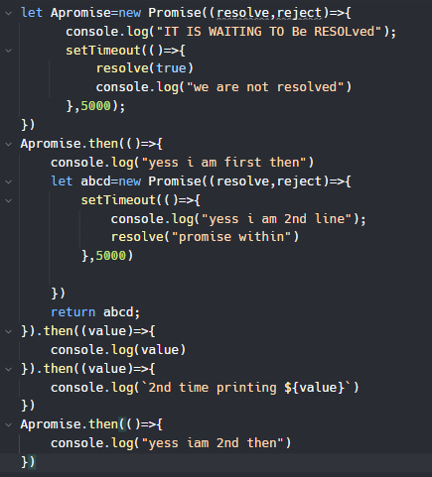

You can attach multiple handlers to the same promise and then will run ek sath or ager ek then ke ander koi promise hai or usse dubara access krna chah rhyho tu fir again.then kr ke new kam sem previous promise ke value se krwa sakty hain

<https://replit.com/@Hasnain150/AttachingMultipleHandlersToaPromise>